

**Report On The Design Thinking Project**

Subject: SECP1513 Technology and Information System

Section: 05

Name of Lecturer: Dr. Azurah binti Abu Samah

Date: 30th November 2023

Title of The Design Thinking Project: The Green Bin

Video Link (YouTube): <https://www.youtube.com/watch?v=CyNe5oUVwBY>

**Group Profile**

| Name: Baraah Alawi Ahmed Mekyash  Matric Number: A20EC4063  E-mail: a.ahmed-2002@graduate.utm.my  Phone Number: 011-6170 7618  Course: Network and Security  E-portfolio Link:  <https://github.com/BaraahM/SECP1513> | Name: Cheng Jia Yi  Matric Number: A23CS0215  E-mail: chengyi@graduate.utm.my  Phone Number: 016-811 7210  Course: Software Engineering  E-portfolio Link: <https://github.com/cheng-jiayi/SECP1513-TIS> | Name: Choh Jing Yi  Matric Number: A23CS0296  E-mail: choh@graduate.utm.my  Phone Number: 011-5506 6709  Course: Bioinformatics  E-portfolio Link:  <https://github.com/chohjingyi/chohjingyi.github.io> |
| --- | --- | --- |
| Name: Muhammad Rosyid Ridho Indrianto  Matric Number: A23CS4017  E-mail: muhammadridho@graduate.utm.my  Phone Number: 017-703 5367  Course: Software Engineering  E-portfolio Link:  <https://github.com/RosyidRidhoo/SECP1513-TIS-05-> | Name: Nur Ayuni Binti Noor Azman  Matric Number: A23CS0257  E-mail: ayuni04@graduate.utm.my  Phone Number: 011-1066 3474  Course: Software Engineering  E-portfolio Link:  <https://github.com/ayuniazman/SECP1513.github.io> |  |

Comments by the grader:

Table of Contents

**Introduction** **2**

**Design Thinking Project Timeline** **3**

Log Journal 3

**Descriptions of the Problems, Solutions and Teamwork** **7**

Problems 7

Solutions 7

Teamwork 8

**Design Thinking Assessment Points** **9**

Empathise Phase 9

Define Phase 9

Ideate Phase 9

Prototype Phase 9

End of the Design Thinking Project 10

**Design Thinking Evidence** **11**

Empathise Phase 11

Define Phase 12

Ideate Phase 12

Prototype Phase 13

**Reflections** **15**

Baraah Alawi Ahmed Mekyash 15

Cheng Jia Yi 15

Choh Jing Yi 15

Muhammad Rosyid Ridho Indrianto 16

Nur Ayuni Binti Noor Azman 16

**Tasks for Each Team Member** **17**

**References** **18**

# 

# Introduction

Design thinking is a methodology which provides solutions to problems through collaboration, design and innovation. Among the five phases of design thinking, the empathise phase involves user-centric research. Further, the define phase involves identifying issues and problems. Next, the ideate phase involves generating ideas and solutions. Then, the prototype phase involves representing the solutions in a physical form. Finally, the test phase involves evaluating the solutions and refining them.

The Design Thinking Project requires the group members to write a report, create a video and prepare a presentation involving design thinking. The project will promote analysis, communication, creativity, problem solving and teamwork among the group members, improving our potential in the industry. This report includes the Design Thinking Project Timeline, Descriptions of the Problems, Solutions & Teamwork, Design Thinking Assessment Points, Design Thinking Evidence, Reflections and Tasks for Each Member.

# 

# Design Thinking Project Timeline

## Log Journal

| **Date** | **Description** | **Images & Pictures** |
| --- | --- | --- |
| 25th October | * Introduction to the group members * Briefing by Dr. Azurah binti Abu Samah regarding the Design Thinking Project |  |
| 1st November | * Conception of the idea for the Design Thinking Project: The Green Bin |  |
| 8th November | **Empathise Phase**   * Interview with Nur Ain binti Noor Azman |  |
| 15th November | **Define Phase**   * Identification of the issues and problems with the traditional waste management system   **Ideate Phase**   * Generation of ideas and solutions * Writing of a report titled Proposed Idea for the Design Thinking Project |  |
| 22nd November | **Prototype Phase**   * Creation of a mind-map, sketch and mobile application mockup * Delegation of tasks for the group members * Starting a report, presentation and video for the Design Thinking Project |  |
| 24th November | * Completion of the report |  |
| 26th November | * Completion of the presentation |  |
| 28th November | * Submission individual videos to the video producer |  |
| 30th November | * Completion of the video * Submission of the report * Submission of the video |  |

# 

# Descriptions of the Problems, Solutions and Teamwork

## Problems

Traditional waste management systems face challenges in monitoring waste fill levels. This leads to inefficient waste collection routes and resource allocation, causing unnecessary fuel consumption, traffic congestion and increased operational costs.

Other than that, overflowing bins are a common sight, contributing to environmental pollution and negatively impacting the overall aesthetics of residential areas. The bins also develop into breeding grounds for pests like mice and insects, inconveniencing the residents and spreading harmful diseases and illnesses.

Lastly, traditional waste management systems do not prioritise recycling. It is difficult to access and navigate the recycling process, causing incorrect waste disposal and contaminated recyclables.

## Solutions

The Green Bin is equipped with sensors that can detect the level of waste within them. Once the bin reaches a certain capacity, the sensor triggers a notification to alert waste management authorities for waste collection. The data is also analysed to predict future fill levels accurately, optimising collection routes and resource allocation.

Other than that, the Green Bin incorporates real-time image recognition, sorting mechanisms and a multi-compartment design, separating recyclables from general waste. This reduces the need for manual sorting and improves the efficiency of the recycling process.

Finally, the Green Bin utilises a user-friendly mobile application. The interface provides users notifications and updates related to the Green Bin. The interface also promotes recycling; users can earn points through recycling and exchange them for rewards.

## 

## Teamwork

All group members collaborated, contributed and cooperated in the process of completing the Design Thinking Project.

From a design thinking standpoint, during the empathise phase, all group members took part in the preparation and documentation for the interview. During the define phase, all group members took part in the identification of the issues and problems. During the ideate phase, all group members took part in brainstorming ideas and solutions. During the prototype phase, all group members took part in translating the ideas generated into a physical model.

From a content creation standpoint, while writing the report, all group members completed their allocated tasks, ensuring a comprehensive and cohesive document. While creating the video, all group members put effort into scripting, filming and editing, ensuring a polished and engaging final product. While preparing the presentation, all group members participated in creation of the slideshow, ensuring that our Design Thinking Project is conveyed clearly and concisely.

The process of completing the project involved regular check-ins and shared deadlines, enhancing the timeliness and overall quality of the final output.

# 

# Design Thinking Assessment Points

## Empathise Phase

The empathise phase focuses on user-centric research. During this phase, the group members collaborated with the interviewee to gain an empathetic understanding of the traditional waste management system. Through in-depth interviews and observations, the group members gained significant information about user habits and challenges related to waste management.

## Define Phase

The define phase focuses on organising the information gathered and defining the problems identified. During this phase, the group members constructed a problem statement highlighting the inability to monitor fills levels of waste bins, neglect of recycling and the secondary problems caused. In conclusion, users need an efficient and effective method to dispose of waste and sort out recyclables.

## Ideate Phase

The ideate phase focuses on ideating innovative solutions to the problem statement. The group members engaged in brainstorming sessions to generate ideas. During this phase, group members generated ideas such as fill level monitoring (fill level sensors and machine learning), recycling features (real-time image recognition, sorting mechanisms and multi-compartment design) and a user-friendly mobile application.

## Prototype Phase

The prototype phase focuses on producing a cost-efficient, scaled-down physical model that represents the project. During this phase, the group members created prototypes to visualise and conceptualise the project. For example, the group members created a mind-map via Lucidchart and a sketch and mobile application mockup via Canva. The prototype also ensures that the Green Bin is compatible with users, addressing their needs and wants.

## End of the Design Thinking Project

Through the design thinking process, the group members transformed insights and observations into a practical solution: The Green Bin. In summary, the project effectively addresses the traditional waste management problems, simplifying waste disposal and promoting recycling. However, continuous evaluation and modifications are necessary for the Green Bin to succeed in a competitive market.

# 

# Design Thinking Evidence

## Empathise Phase

During the empathise phase, the group members conducted an interview to gain an empathetic understanding of user habits and challenges related to waste disposal. The interview notes are as follows:

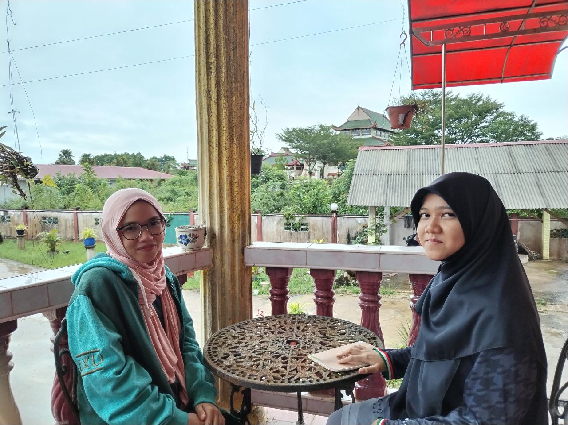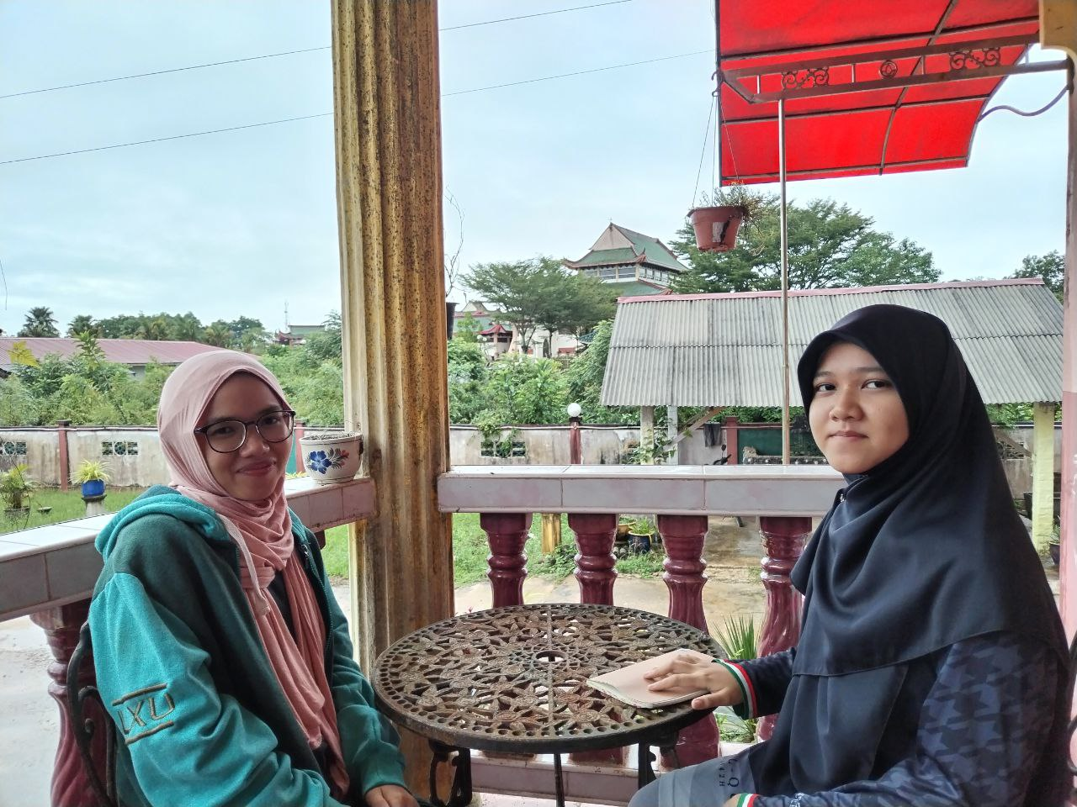

Figure 5.1 and Figure 5.2: Documentation of the Interview

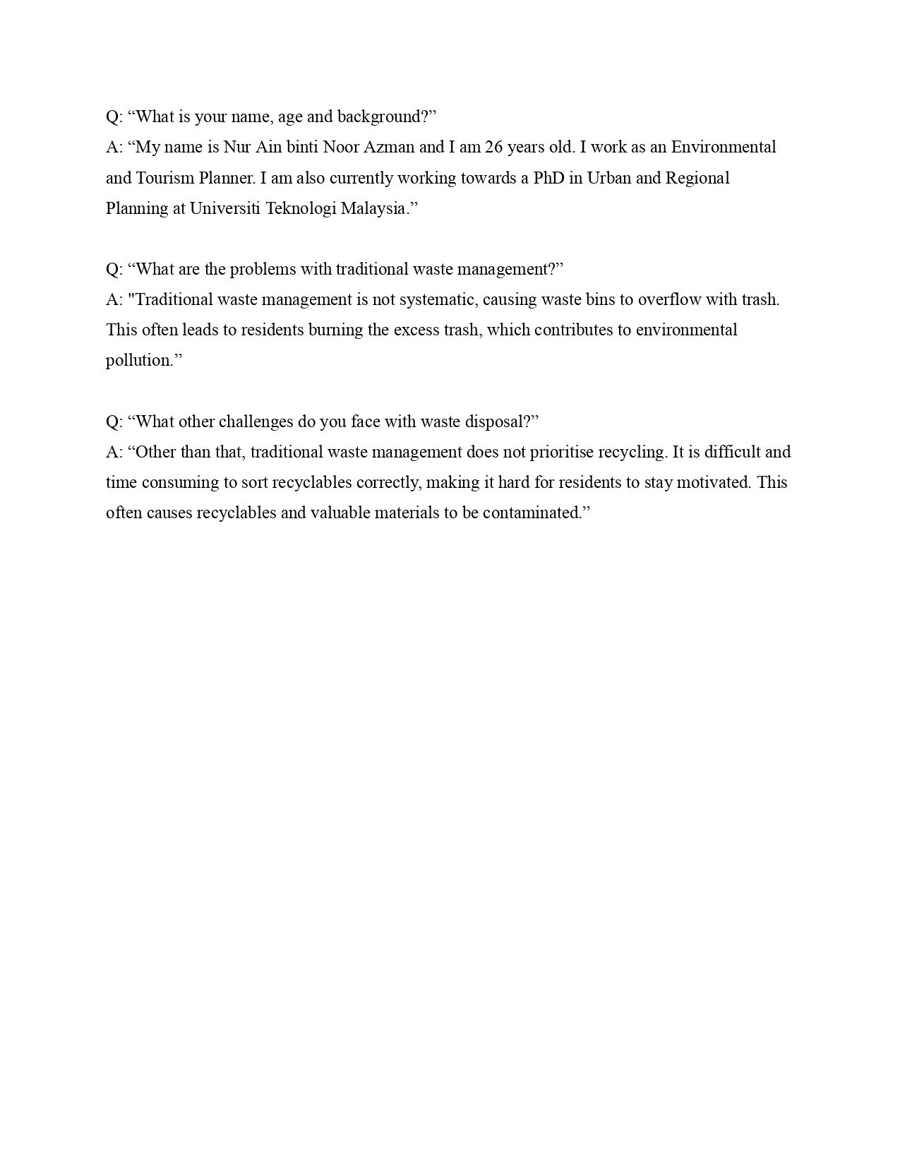

Figure 5.3: Interview Transcript

## Define Phase

During the Define phase, the group members went through the interview notes to identify and outline the problems related to waste disposal. To visualise the problems, a mind-map was constructed using Lucidchart.

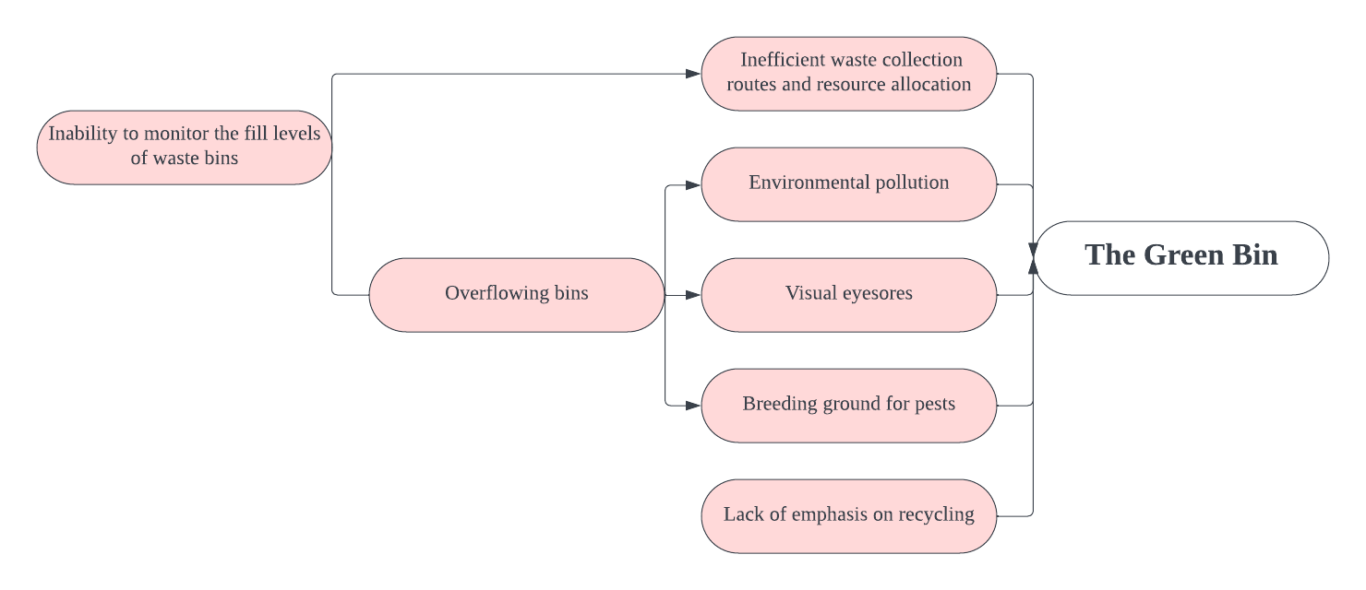

Figure 5.4: Mind-map of Problems

## Ideate Phase

During the Ideate phase, the group members brainstormed and generated multiple ideas and solutions. To visualise the solutions, a mind-map was constructed using Lucidchart.

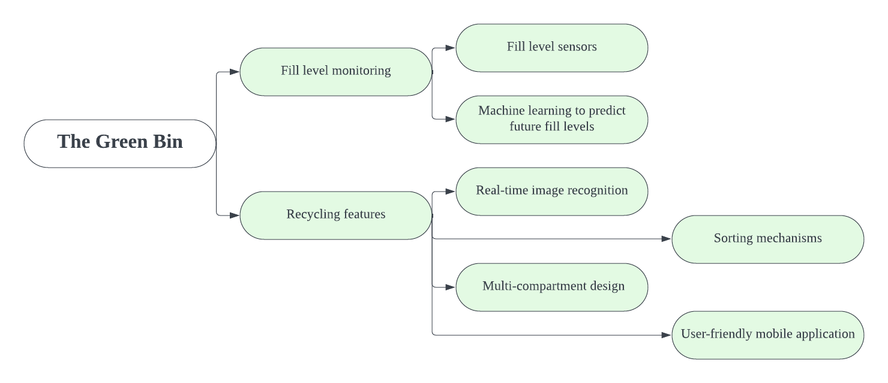

Figure 5.5: Mind-map of Solutions

## Prototype Phase

During the prototype phase, the group members created a mind-map via Lucidchart, a sketch and a mobile application mockup via Canva. Notably, the mobile application mockup has a Sign In page, Sign Up page, Loading page, Home page, Points and Rewards System and a Profile page.

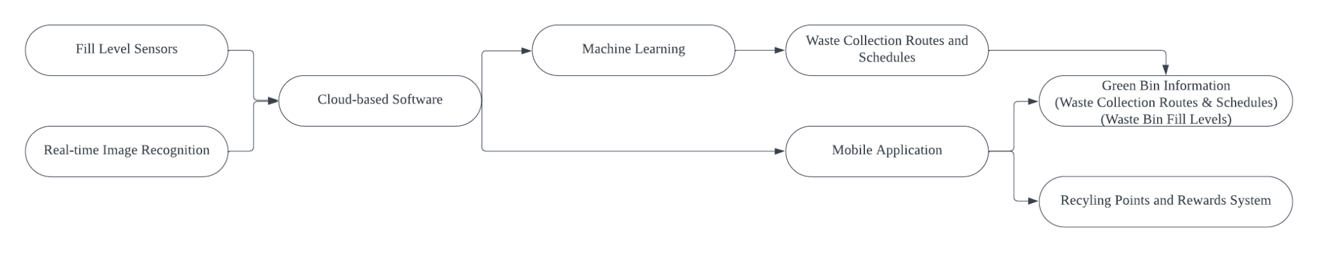

Figure 5.6: Mind-map of Data and Information Flow

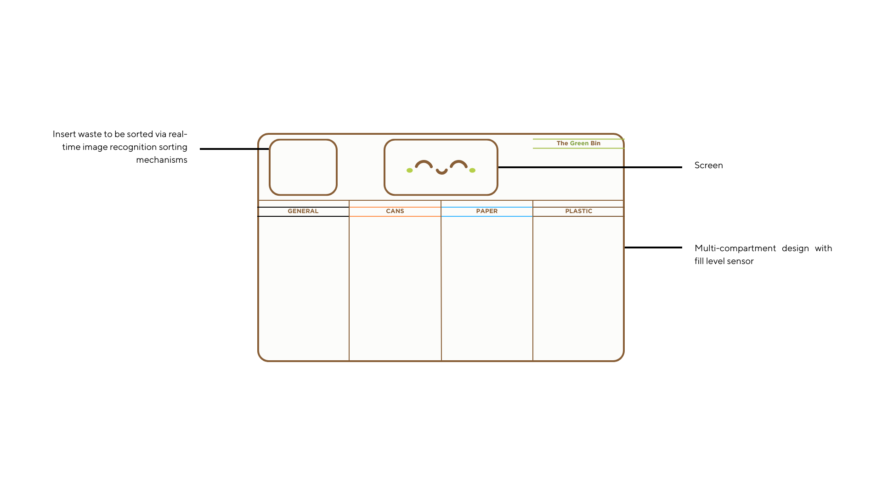

Figure 5.7: Sketch of the Green Bin

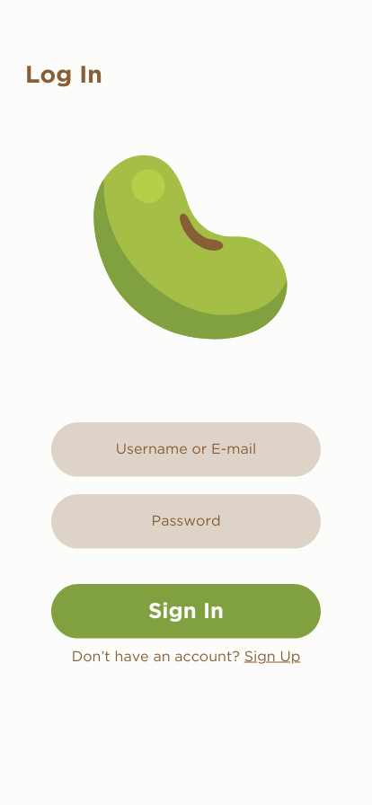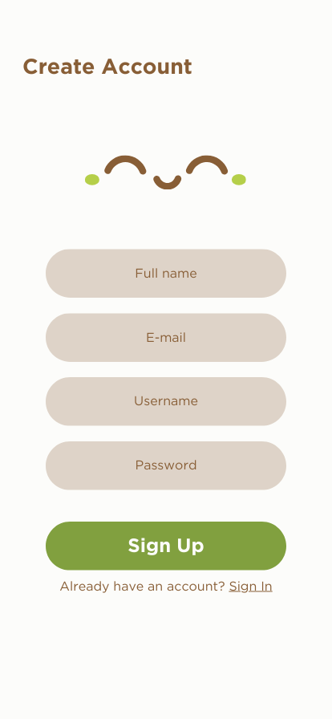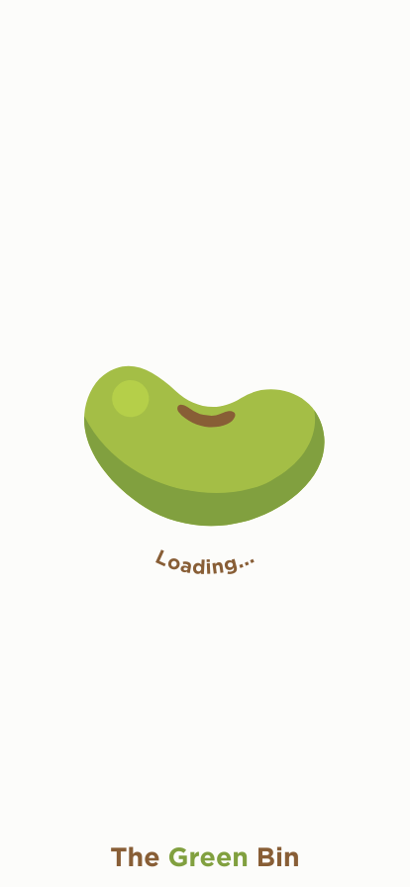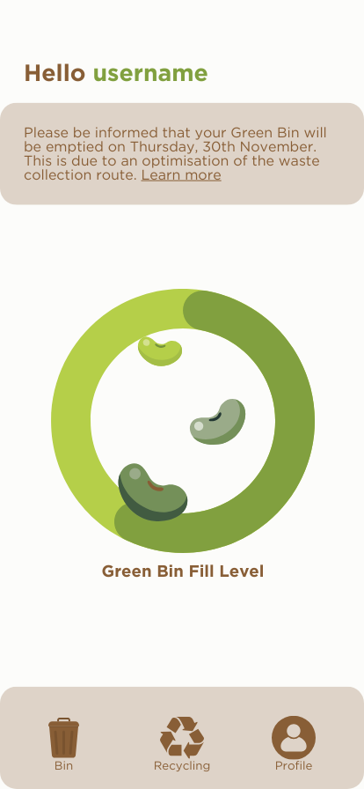

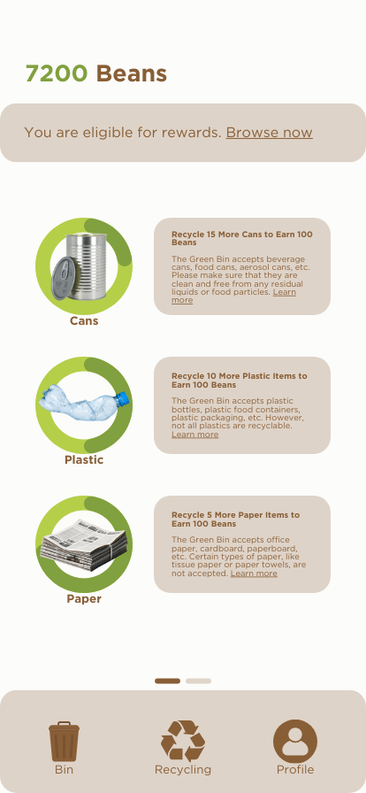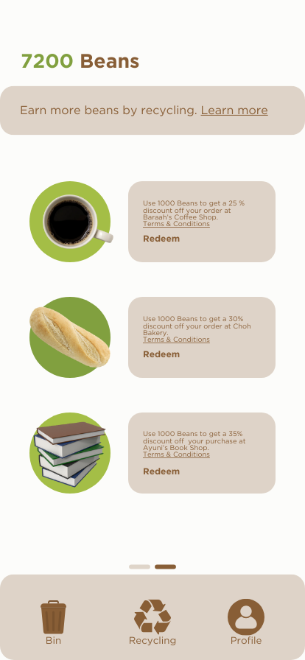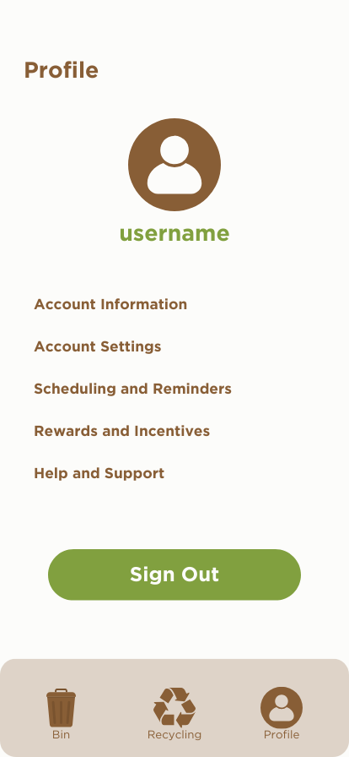

Figure 5.8: Mobile Application Mockup

# Reflections

## Baraah Alawi Ahmed Mekyash

As a Network and Security student, I aim to become a skilled cybersecurity expert, protecting digital assets and data. Our project highlighted the importance of design thinking; it encourages proactive, user-centric approaches and emphasises the importance of understanding user behaviour. The project also underscored the value of teamwork and efficient communication. To sum up, I want to excel in threat reduction and network defence. Therefore, I intend to participate in group projects, gain real-world experiences, acquire a broad skill set, engage in continuous learning and pursue ongoing education.

## Cheng Jia Yi

Through the Software Engineering course, I aspire to achieve proficiency in software development and to pursue a career in this field. In regards to my aspirations, design thinking can enhance my ability to create user-centric and efficient solutions, setting me apart in the industry. In order to improve my potential in this field, I will gain practical experience through internships or work opportunities, which provide valuable insights and exposure to industry standards. I will also create a portfolio showcasing my projects, as this demonstrates my skills and provides tangible evidence of my experience.

## Choh Jing Yi

In the Bioinformatics program, I strive to bridge computational sciences and biology, promoting healthcare through technology. Design thinking is crucial as it encourages creative problem-solving through empathy, brainstorming and prototyping. To boost my industry potential, I will focus on mastering tools for high-throughput DNA sequencing and refining my programming skills in Python, Java and Matlab. This skill set will enable me to analyse biological data, advancing computational biology and healthcare. My long-term plan involves continuous learning and patience in exploring novel technologies.

## 

## Muhammad Rosyid Ridho Indrianto

In my Software Engineering studies, I aim to advance my career and deepen my knowledge of software and programming. I also aim to develop and maintain impactful programs. Design thinking is pivotal, ensuring that my programs are user-centric. It also fosters creativity, collaboration, iteration and problem-solving skills. To improve my potential in the industry, I plan to strengthen my understanding of programming fundamentals, data structures and algorithms. I will also develop essential soft skills such as adaptability and communication, network and join online communities.

## Nur Ayuni Binti Noor Azman

As a Software Engineering student, I aspire to be an exceptional programmer, developing a programme that contributes to the well-being of others. Yet, achieving this goal involves overcoming various ups and downs. Developing our design thinking project requires effort for a successful outcome. Through this process, I've learned more about teamwork and the importance of each design thinking phase. This experience also enhances my communication skills, which are crucial for collaborative efforts. Moving forward, I'm committed to improving both my soft skills and programming abilities to enhance my prospects in the industry.

# Tasks for Each Team Member

| **No.** | **Group Member** | **Task** |
| --- | --- | --- |
| **1.** | Baraah Alawi Ahmed Mekyash | * Photography * Videography * Brainstorming * Writing the Report (Design Thinking Project Timeline, Reflections) * Preparing the Presentation |
| **2.** | Cheng Jia Yi | * Videography * Brainstorming * Creation of the Prototypes * Writing the Report (Introduction, Reflections, Tasks for Each Member) * Preparing the Presentation * Video Production |
| **3.** | Choh Jing Yi | * Videography * Brainstorming * Writing the Report (Design Thinking Assessment Points, Reflections) * Preparing the Presentation |
| **4.** | Muhammad Rosyid Ridho Indrianto | * Videography * Brainstorming * Writing the Report (Design Thinking Evidence, Reflections) * Preparing the Presentation |
| **5.** | Nur Ayuni Binti Noor Azman | * Photography * Videography * Conducting the Interview * Brainstorming * Writing the Report (Descriptions of the Problems, Solutions and Teamwork, Reflections) * Preparing the Presentation |

# 

# References

Friis, Rikke. “The 5 Stages in the Design Thinking Process.” The Interaction Design Foundation, 16 October 2023, <https://www.interaction-design.org/literature/article/5-stages-in-the-design-thinking-process>.